Gaming Keyboard
With Multi-Coloured Lighting Effects
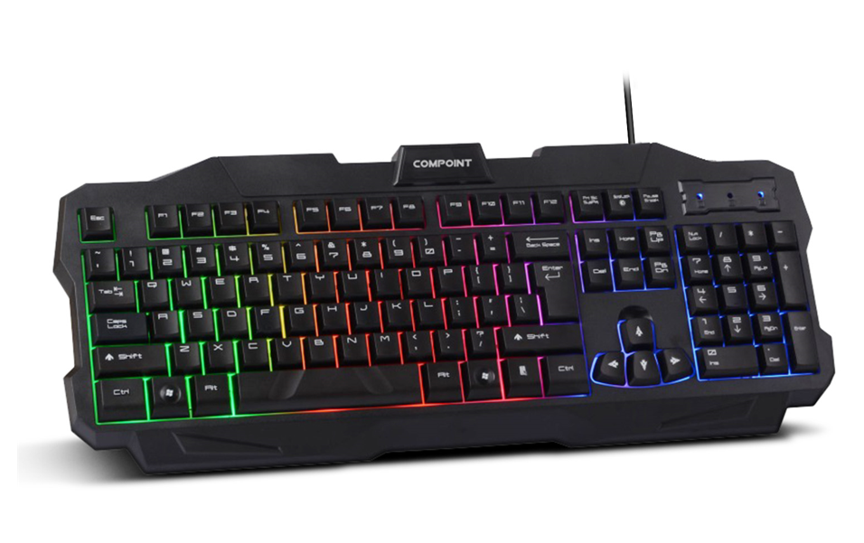

Descrption:

Looking to replace your dull and boring USB keyboard with something that looks great next to your PC, Mac, Media Centre or Project Computer?

The new CP-K8800 is a fully-featured multimedia keyboard with an integral three-colour LED lighting matrix which produces an ambient lighting effect across all keys, with a pleasant colour arrangement.

Great for gamers that like to help create an exciting atmosphere in low-light environments, the CP-K8800 helps users emphasize specific keys and functions not just for games but also for business and leisure applications.

Designed to help promote a more natural and restful typing experience, reducing common problems normally associated with poorly designed keyboards. Whisper quiet in operation with a full size form-factor, separate numeric pad and a generous 1.5m (approx.) USB connection cable.

Ideal For WindowsTM, MacTM, LinuxTM and Raspberry PITM

Fully Plug n' Play for all popular operating systems including Windows10TM, Mac OS XTM LinuxTM and almost any project computer including the Raspberry PITM. Ideal for media centres that use a standard USB keyboard interface and AndroidTM based systems that allow USB keyboard entry - all totally driverless in operation!

Features:

Compact and stylish

Ideal for Notebooks and Tablets

Low-profile with tactile feedback

Standard USB Plug n' Play interface

Durable, approx. 10 million keystrokes

Common multimedia control buttons

WindowsTM shortcut keys

Raspberry PITM compatible

Specifications
Advanced 3-Colour Matrix LEDs
Exciting Lighting Effects
Ideal For Gamers And General Users
Full-Size USB Connected Keyboard
Durable Keys - Approx 10 Million Keystrokes
PnP And Driverless Operation
Tasteful Design With Modern Font Designs
Separate Numeric Pad With LED Status

Product Code:
Part number: CP-K8800-V2
Barcode: 8400800036759
Size: 465*182*25mm
Weight: 0.760 kg

